North Tees and Hartlepool NHS Foundation Trust | Specialist Portfolio – Discipline Specific Knowledge 7.8c Diagnosis of Cardiovascular Disease (Acute)
Directorate of Clinical Pathology | Working Copy- version 1
Biochemistry | Printed:

7.8c Diagnosis of Acute Coronary Syndrome (ACS)

Short notes:

1. What is meant by Acute Coronary Syndrome (ACS)? Ensure you use the following terms:
      - Ischaemia
      - Infarction

2. The following tests can be used to aid the diagnosis of ACS:

      - AST
      - LD
      - CKMB
      - Myoglobin
      - Creatinine
      - Cardiac Troponin (I)
      - CK

State briefly the metabolic role, reference range and method used for each.

3. Draw a graph that shows a (approximately) traditional cardiac release pattern for cardiac enzymes (CK, CKMB, AST and LDH) and Troponin. One axis should be labeled with time the other with assay activity.

4. What is an isoenzyme and what are the types and sources of Ck and LD isoenzymes.

5. The image below shows the structure of Troponin - a protein complex that regulates muscle contraction:
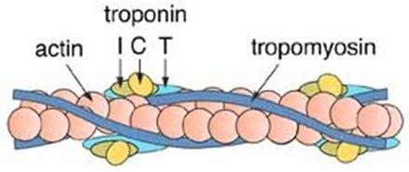

Describe how this protein works during muscle use.

6. What diagnostic algorithms are used for the interpretation of CKMB and Troponins?

7. Why are cardiac Troponin I and T ideal biological markers for detecting cardiac damage in ACS?

8. What is meant by clinical sensitivity and specificity?

9. In your own words discuss what impact laboratory results may have on the treatment of a patient presenting with ACS.

10. What in-vivo and in-vitro factors can influence analytes discussed in this section?

11. What POCT assays are available for cardiovascular markers? Why are none of these in use at North Tees?

