North Tees and Hartlepool NHS Foundation Trust | Specialist Portfolio – Discipline Specific Knowledge 7.6
Directorate of Clinical Pathology | Working Copy- version 2
Biochemistry | Printed:

7.6 Liver Function and Disease States

Short notes:

1. With the aid of a diagram briefly describe the metabolism and excretion of bilirubin (include the metabolism and breakdown of haemoglobin).

2. The image below summarises the metabolic pathways for protein, carbohydrate and fat metabolism in the Liver. Briefly describe each pathway.

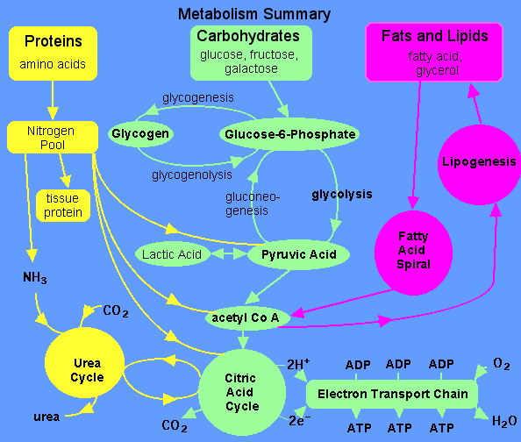

3. The liver is able to detoxify drugs and foreign compounds in numerous ways. It can transform fat-soluble toxins into a water-soluble form. This enables them to be released through the kidneys for elimination in urine, or into bile for elimination through the colon. Enzymes can also be produced that chemically break down toxins which have been absorbed through the intestines. The toxins are either neutralised, or converted into a more chemically active form which is then neutralised, to be safely excreted. Describe in more detail how the liver detoxifies ethanol.

4. Briefly describe the following disease processes and their management:

- Cholestatis
- Hepatitis
- Cirrhosis
- Malignancy

5. List the main causes of pancreatitis and its key laboratory diagnosis.

6. Describe Obstetric cholestasis and the main test used in UHNT to diagnose it.

7. Briefly discus the epidemiology of liver disease according to race, age and sex.

8. Complete the following table:

Assay | UHNT Method | Ref range | Raised in
Total Bilirubin
Direct Bilirubin
Total Protein
Bile Acid
AST
ALT
GGT
ALP
Amylase
Albumin
ALP

9. Describe the synthesis of Albumin in the liver.

10. What are the metabolic functions of the liver enzymes listed in question 8 above

11. Describe ALP isoenzymes.

12. What is the role and function of Ceruloplasmin.

13. Briefly describe the function (s) of the following specific proteins and how they are usually measured in the laboratory:

- gamma-globulins
- alpha-fetoprotein
- alpha1-antitrypsin

14. Briefly discus the principles and limitations of diagnostic enzymology.

15. What are the major causes of hepatic jaundice (include pre and post hepatic).

16. List the major inherited abnormalities of bilirubin metabolism.

17. Briefly describe Gilbert’s syndrome and the laboratory findings you would expect to find.

18. What is urobilinogen and how does it occur in the body?

19. List the analytical and sample factors that can affect Liver Functions Tests.

20. What is the significance of abnormal bilirubin in: -

- Plasma
- Urine

21. Describe the link between the measurement of Total protein, albumin and secondary globulin estimation. Explain the significance of abnormalities in globulin fraction (A/G ratio).

