North Tees and Hartlepool NHS Foundation Trust | Specialist Portfolio – Discipline Specific Knowledge 7.8a Major Lipids and Disease
Directorate of Clinical Pathology | Working Copy- version 1
Biochemistry | Printed:

7.8a Major Lipids in Atherosclerosis and Cardiovascular Disease

Short notes:

- The image below shows lipid breakdown, transport and storage in the body.

  - Describe how dietary fat is broken down and transported to the liver and tissues in the exogenous pathway.
  - Describe how lipids are transported from the liver to tissues (adipose and non-liver cells) in the endogenous pathway.
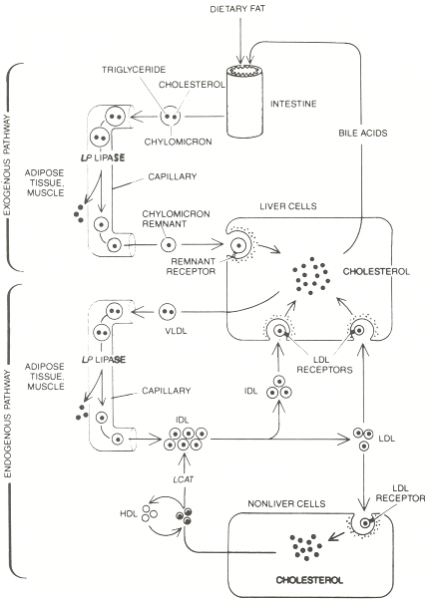

2. The image below shows a diagrammatic view of the 5 classes of lipoprotein:

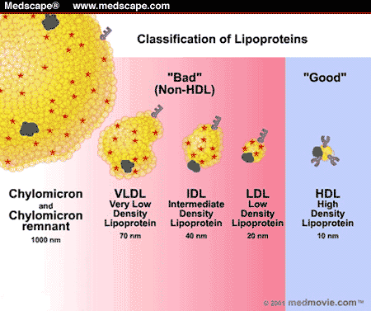

Because lipids are not soluble in water they must be packaged in some way in order to be suspended in the plasma. As lipids pass through the gastrointestinal system, they are packaged as chylomicrons, secreted into the circulation, transformed into chylomicron remnants, and then finally transported to the liver. There they are repackaged as a series of smaller, denser lipoprotein "particles" as shown above. Briefly describe the composition, metabolism and principle function of each lipoprotein class and what is meant by “good” and “bad” cholesterol.

3. What are phospholipids and what role do they play in the body?

4. What is hypercholesterolemia and why is it a risk factor in Coronary Heart Disease?

5. The treatment of hyperlipidaemia (relevant to latest NICE guidelines) for prevention of Cardiovascular Diseases is divided into primary and secondary treatment pathways. What is meant by this? Also list the assessments and treatment given for each. (Note: Nice Guidelines for Hyperlipidaemia can be found on the CPD sharepoint in the reference folder).

6. Fill in the following diagram boxes to briefly describe Atherosclerosis:

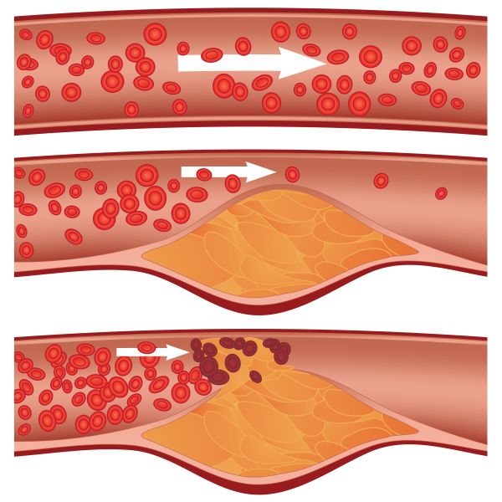
1.

2.

3.

7. What is Acute Coronary Syndrome (ACS) and how is it diagnosed and treated.

8. What tests are carried out at N. Tees Hospital for:

- Coronary Heart Disease (e.g. acute MI)
- Chronic Heart Failure

Briefly describe each test. (Note: use Cardiac Biochemical Markers presentation in CPD sharepoint folder)

9. What are the main causes and treatment of Chronic Heart Failure?

10. What are fatty acids and what role do they play in the body?

