North Tees and Hartlepool NHS Foundation Trust | Specialist Portfolio – Discipline Specific Knowledge Section 7.2
Directorate of Clinical Pathology | Working Copy- version 1
Biochemistry | Printed:

7.2 Laboratory Automation

- What assays are measured on the AU 5800 chemistry analyser using ISE method - with the aid of a diagram explain how the ISE method works.

- The following are key automated steps (not in order) for processing a sample on the AU 5800 series:

  - Sample assay and incubation.
  - Sample ISE aspiration.
  - Sample identification.
  - Sample result data transmission.
  - Sample sorting and aliquoting.
  - Sample upload ordering.
  - Sample moved to buffer area pending assay completion.
  - Sample Colourimetric/Spectrophotometer aspiration.

Using your own words produce a flow chart on how a glucose sample is processed (include analyser assay method) from first receipt within the department to final archiving in the cold room. Ensure the above steps are also included.

- Describe the name, location and function of the key mechanical components of: (Demonstration/discussion only)
  - Beckman Coulter AU 5800 series
  - Beckman Coulter DxI analyser
  - Beckman Coulter Automate
  - Roche Cobas e 411
  - Roche Cobas b123 blood gas analyser

- A spectrophotometer is employed to measure the amount of light that a sample absorbs. The instrument operates by passing a beam of light through a sample and measuring the intensity of light reaching a detector. What instruments in the chemistry laboratory use this technique?

- Label the following diagram (arrows) demonstrating the immunoassay principle in your own words:
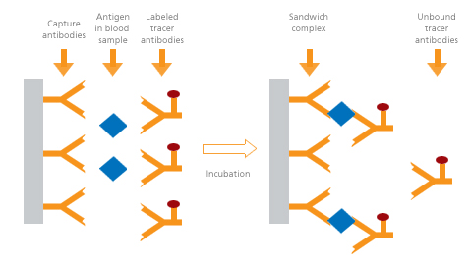

- List 2 assays in the chemistry laboratory that can be measured using ‘electrochemistry’ methods?

- List the software you use on a daily basis in the chemistry laboratory and where they are used.

- What are the main factors affecting sample integrity?

- How often do we run internal quality control on the following main analysers:

  - Beckman Coulter AU 5800 series
  - Roche Cobas e 411
  - Roche Cobas b123 blood gas analyser

- List the maintenance procedures for each of the following chemistry analysers (daily and weekly only).

  - Beckman Coulter AU 5800 series
  - Roche Cobas e 411
  - Roche Cobas b123 blood gas analyser

- Complete the following table:

Assay short name | Full name | Raised in: (either clinical / artefact) | Lowered in: (either clinical / artefact)
ALP
ALT
CREA
GGT
K
NA
ALB
URE
CRP
BIL
CA
PHO
AST

- List the sample types and containers used that can be analysed within this Biochemistry department.

