North Tees and Hartlepool NHS Foundation Trust | Specialist Portfolio – Discipline Specific Knowledge 7.5
Directorate of Clinical Pathology | Working Copy- version 1
Biochemistry | Printed: 26/10/2013

7.5 Kidney Disease

Short notes:

1. Label the anatomy of the kidney diagram below:

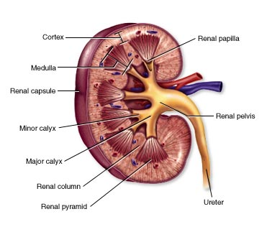

2. Briefly describe the function (s) of the kidney.

3. List the common pathologies that affect the kidney (state whether the condition is chronic or acute).

4. List the laboratory investigations to determine renal function and glomerular filtration rate (GFR). How is GFR calculated at UHNT and what variables can influence the calculation.

5. Pictured below is a Nephron – the functional unit of the kidney. Briefly describe the function of each labeled component.

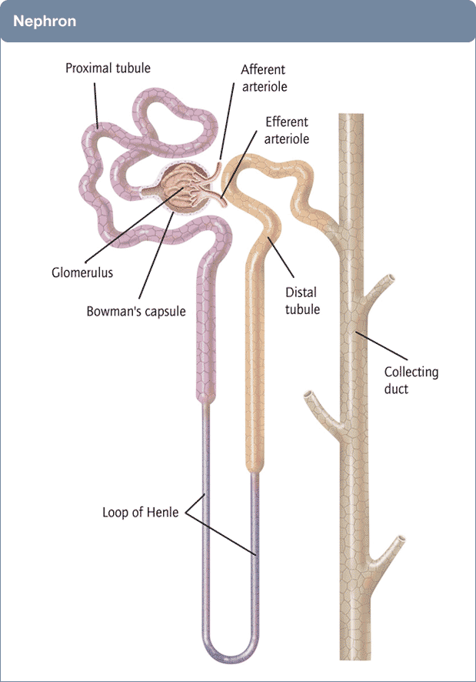

6. How can Chromium EDTA be used to determine GFR.

7. Describe the assay methods used at UHNT to determine total protein and microalbumin in urines.

8. Describe the ALCR test and how it is used to monitor renal disease in diabetics

9. Briefly describe other laboratory assays that are performed on urines at UHNT.

10. List serum laboratory tests that may be impaired/altered by renal disease.

11. How is chronic renal disease categorised clinically.

12. Briefly describe how vitamin D and PTH can be altered during renal disease.

13. Briefly describe how the kidney affects Haemoglobin concentration.

14. Describe the creatinine assay method used at UHNT and how this waste product is produced by the body.

15. The MDRD equation and Creatinine clearance test can both be used to determine the glomerular filtration rate. Briefly describe each method.

16. Describe the procedure followed if an UE profile generated the following flags:
AKI1
AKI2
AKI3

